**SUSTAINABLE OUTREACH AND UNIVERSAL LEADERSHIP LIMITED  
(SOUL)**



**STUDENT LIFE CYCLE MANAGEMENT**

**GAP ANALYSIS DOCUMENT (ADMISSION)**

Catalog

A. Introduction 3

B. List of Screen 4

C. ADMISSION 5

1. Masters 6

1.1 Department 6

1.2 Program Grades 6

1.3 Programs 7

1.4 Semester 7

1.5 Courses 7

1.6 Academic Year 8

1.7 Academic Term 9

2. Student And Instructor 9

2.1 Student 9

2.2 Instructor 11

2.3 Student Category 12

2.4 Student Batch Name 12

3. Admission Master 12

3.1 Academic Events 12

3.2 Academic Calender Template 12

3.3 Eligibility Parameter 13

3.4 Documents Template 13

4. Application and Enrollment 14

4.1 Student Admission 14

4.2 Student Applicant 16

4.3 Program Enrollment 18

4.4 Course Enrollment 19

5. Councelling 20

5.1 Councelling Structure 20

5.2 Place Selection Master 20

5.3 Entrance Exam Declaration 21

5.4 Entrance Exam Center Allocation 22

5.5 Admit Card Generation Tool 22

5.6 Entrance Exam Admit Card 23

5.7 Entrance Exam Evaluation 23

5.8 Rank Card Publication Tool 24

5.9 Rank Card Publication Masters 24

6. Fees 24

6.1 Fee Structure 24

6.2 Fee Schedule 25

6.3 Fee Category 26

6.4 Fees 26

7. Tools 27

7.1 Student Re registration Tool 27

# **Introduction**

A gap analysis is an examination and assessment of the current performance for the purpose of identifying the differences between the current state of product and where you’d like to be.

Conducting a gap analysis can help us to improve our product and profitability by allowing us to pinpoint “gaps” present in our software. Once it’s completed, we will be able to better focus on our resources and energy on those identified areas in order to improve them.

# **List of Screen**

|  |  |  |  |
| --- | --- | --- | --- |
| SL no | Name of the Screens | Changes in Existing | Is New Screen ? |
|  | Department | No | No |
|  | Program Grade | No | No |
|  | Program | Yes | No |
|  | Semester | Yes | No |
|  | Course | Yes | No |
|  | Topic | Yes | No |
|  | Class Room | No | No |
|  | Academic Year | No | No |
|  | Academic Term | No | No |
|  | Document Template | Yes | No |
|  | Academic Calendar | Yes | No |
|  | Student Admission | Yes | No |
|  | Student Applicant | Yes | No |
|  | Program Enrollment | Yes | No |
|  | Course Enrollment | Yes | No |
|  | Student | Yes | No |
|  | Instructor | Yes | No |
|  | Student Re registration Tool | Yes | No |
|  | Student Category | Yes | No |
|  | Student Batch | No | No |
|  | Fee Category | Yes | No |
|  | Fee Structure | Yes | No |
|  | Fee Schedule | Yes | No |
|  | Fees | Yes | No |
|  | Academic Event | No | No |
|  | Documents | No | No |
|  | Awards | No | No |
|  | Fee Types | No | No |
|  | Student Identity Card |  | Yes |
|  | Identity Card Tool |  | Yes |

# **ADMISSION**

**Existing Student Admission Process Flow**

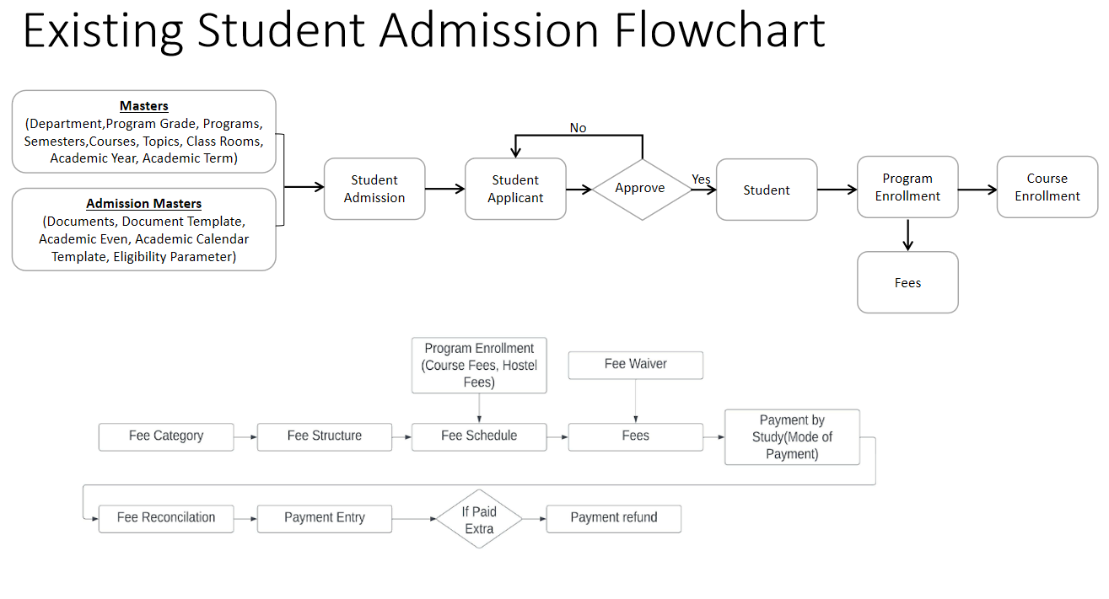

**WSC Student Admission Process Flow**

Entrance Exam Process

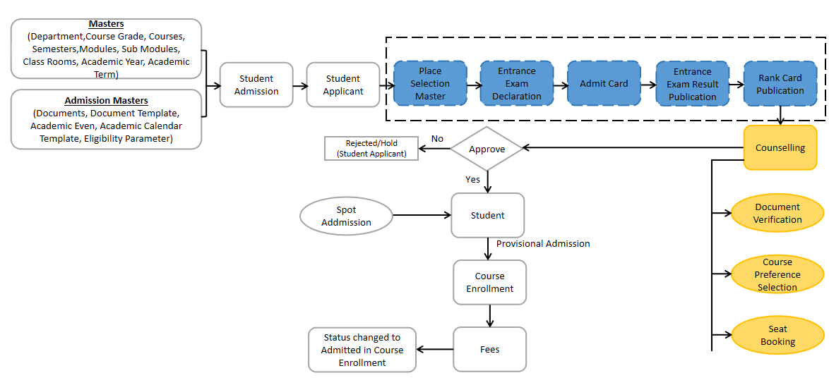

- No Change

- Gap Between Existing and WSC Process Flow

- Addition to the Scope

## **Masters**

### **Department**

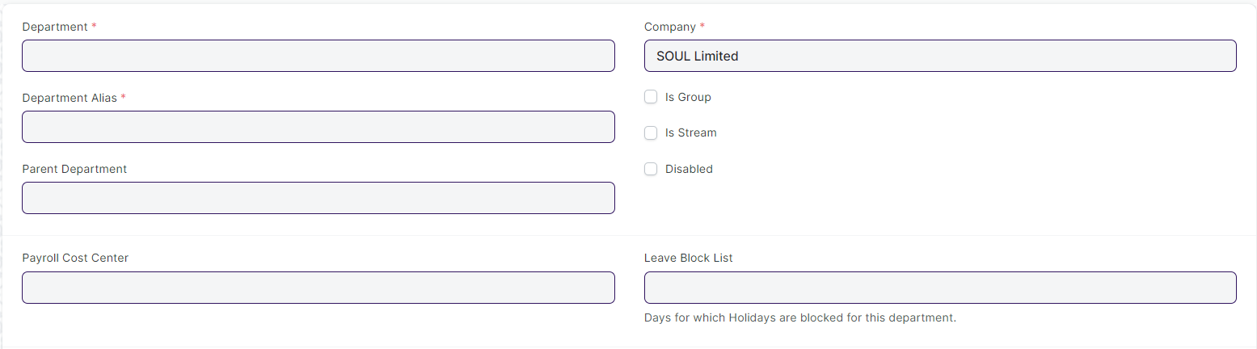

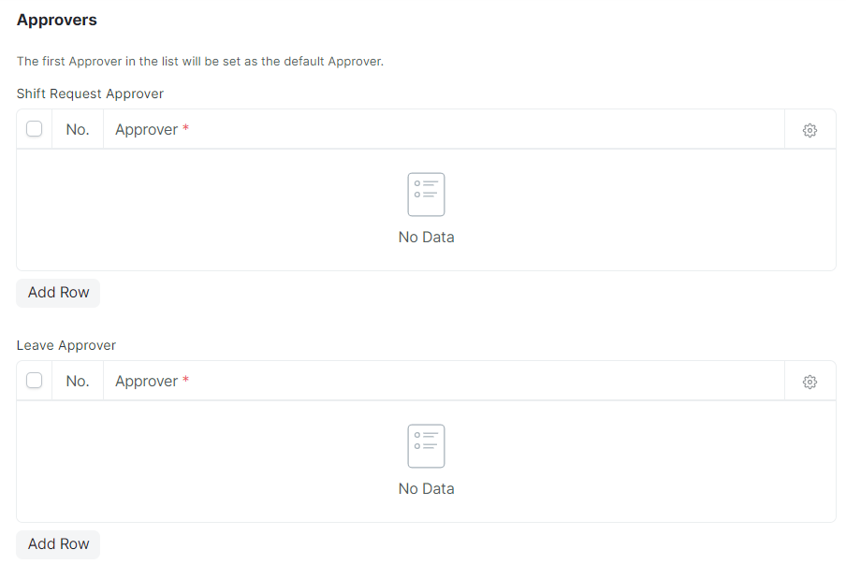

#### **Business Requirements:**

* No changes needed as discussed.

### **Program Grades**

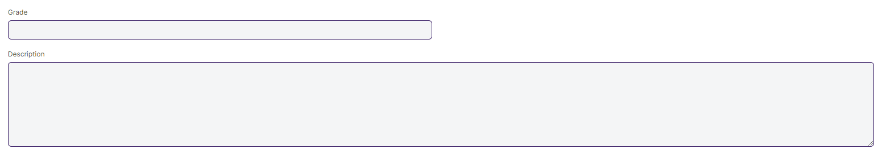

#### **Business Requirements:**

* Change the name of Program Grades to Course Grade.

### **Programs**

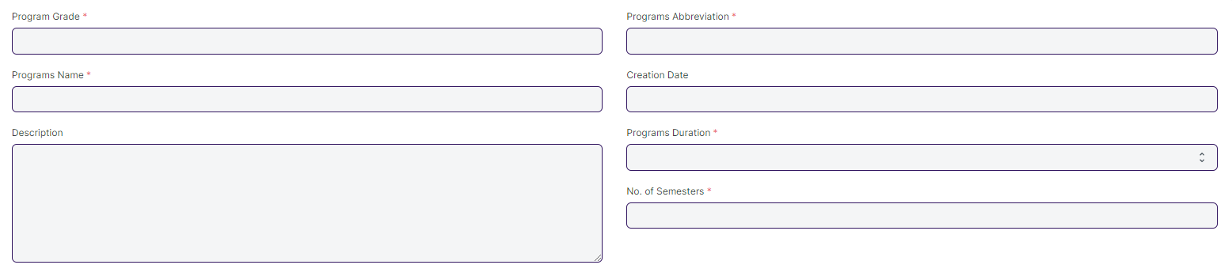

#### **Business Requirements:**

* The following name will be change:

1. Programs to Course
2. Program Grades to Course Grade
3. Programs Name to Course Name
4. Programs Duration to Course Duration

### **Semester**

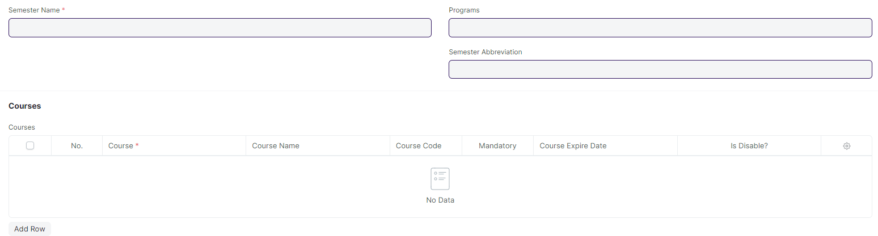

#### **Business Requirements:**

* No changes needed as discussed.

### **Courses**

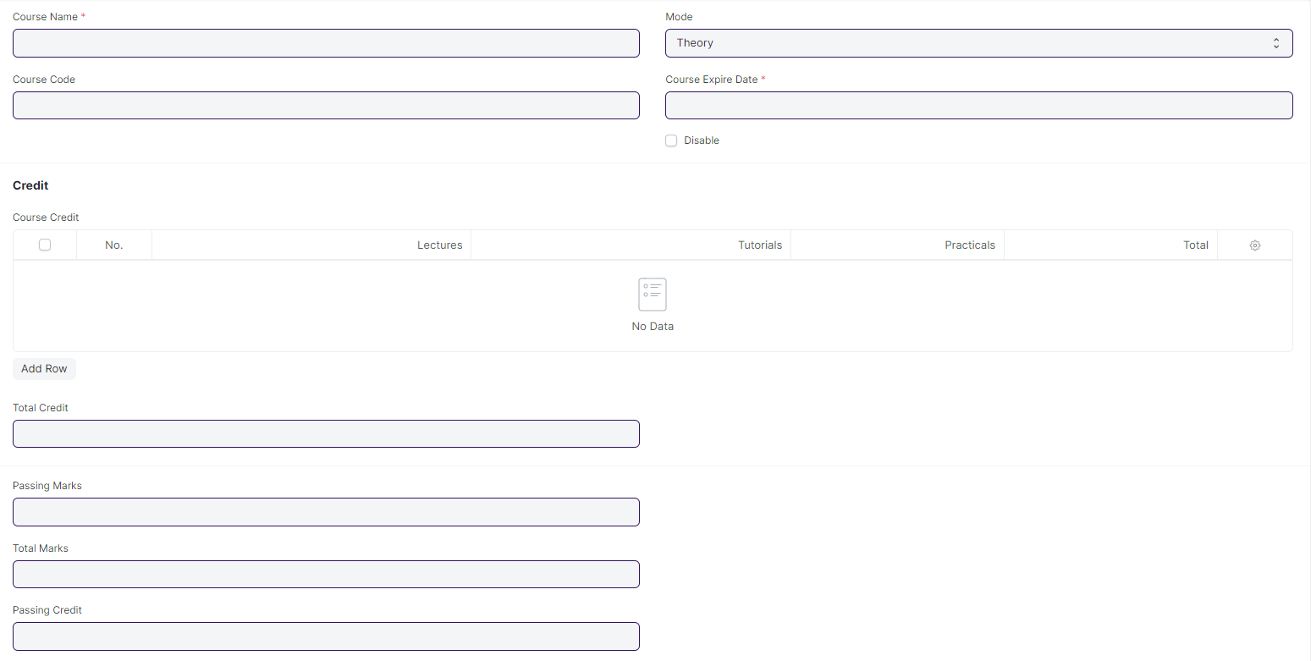

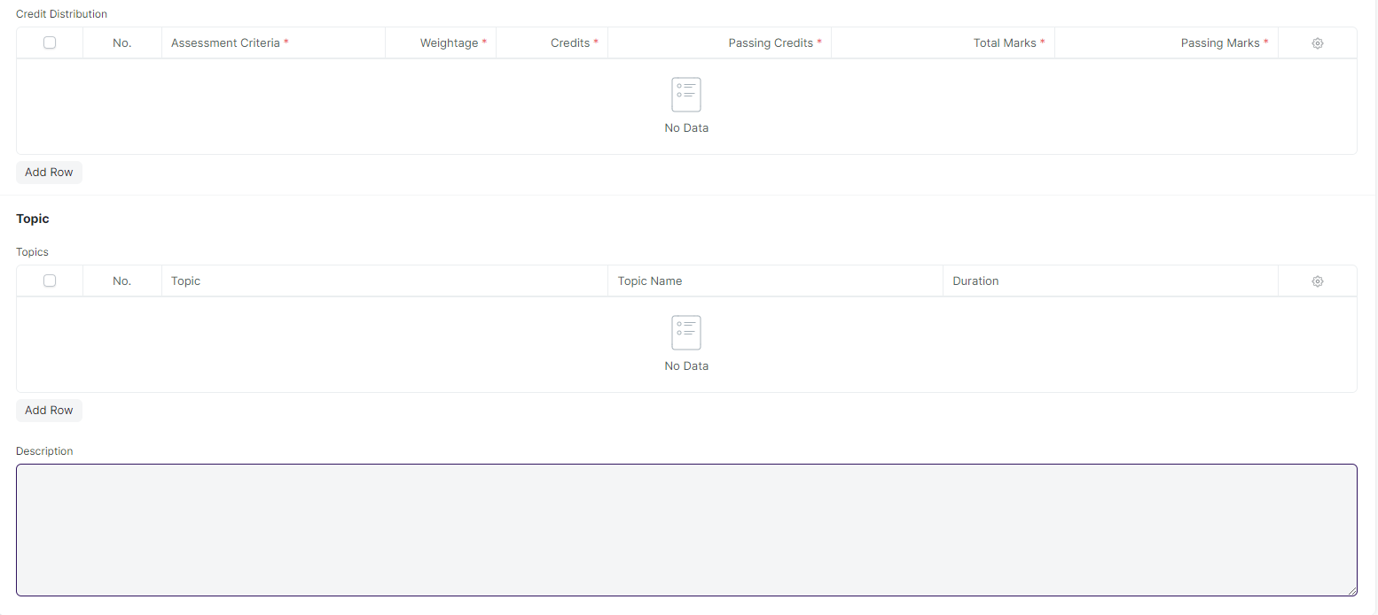

#### **Business Requirements:**

* The following name will be change:

1. Courses to Modules
2. Course Name to Module Name
3. Course Code to Module Code
4. Course Expire Date to Module Expire Date

* In Course screen's Topic table needs to be expanded to include the topic description field and a button for attaching the lesson plan.
* All the fields and table which is related to credit need to be hidden or deleted.
* In Topic Table following fields need to be added:

1. Topic Description.
2. Attach field for uploading the lesson plan.

### **Academic Year**

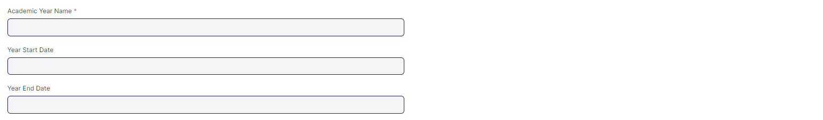

#### **Business Requirements:**

* No changes needed as discussed.

### **Academic Term**

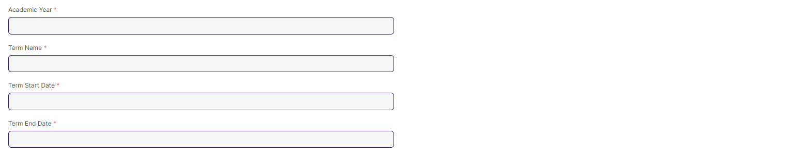

#### **Business Requirements:**

* No changes needed as discussed.

#### **Room****Business Requirements:**

* No changes needed as discussed.

## **Student And Instructor**

### **Student**

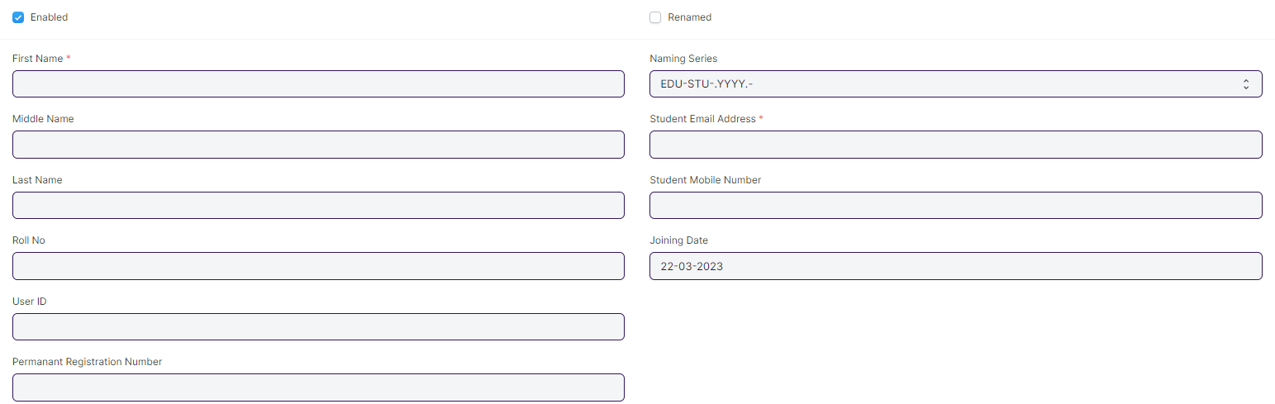

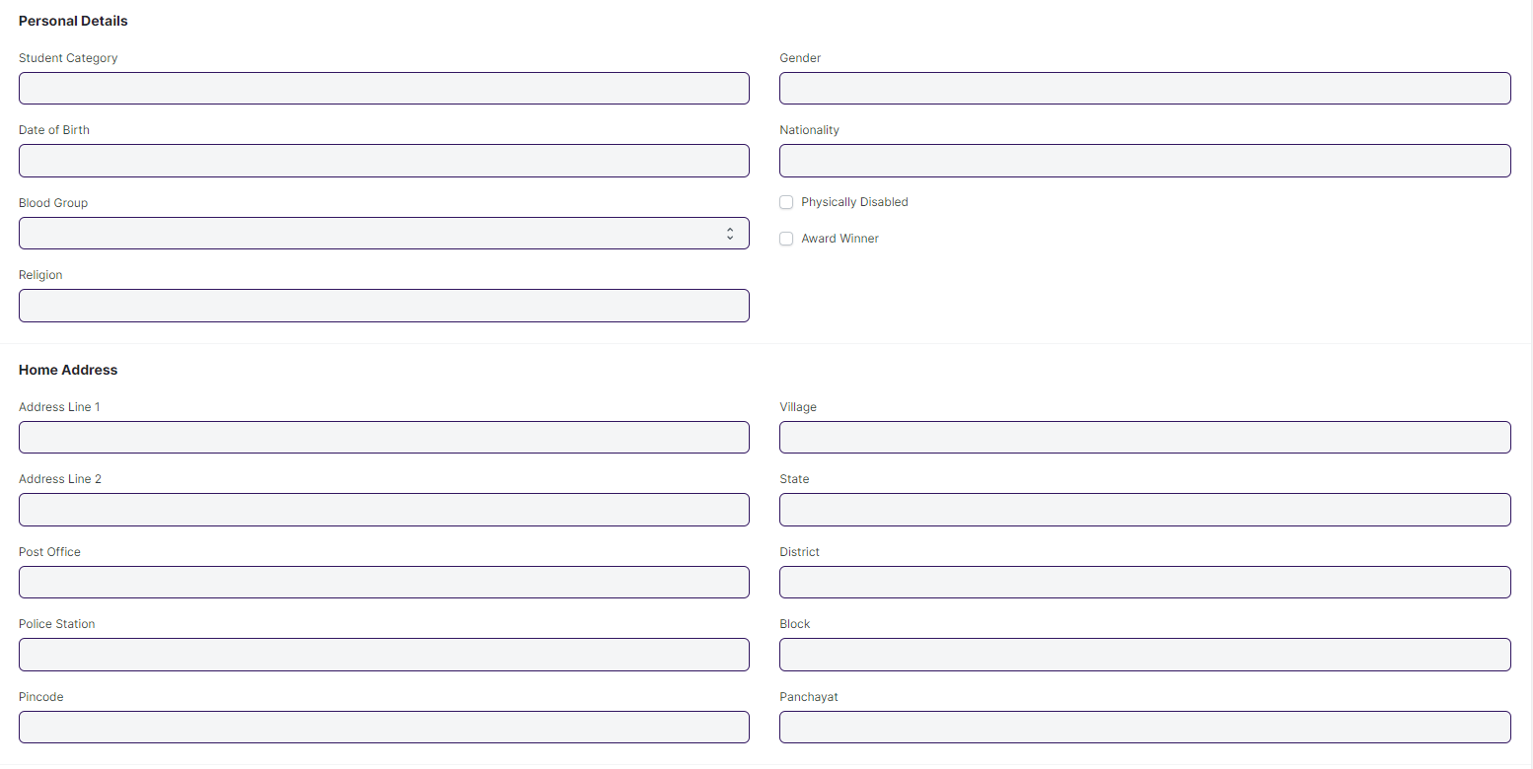

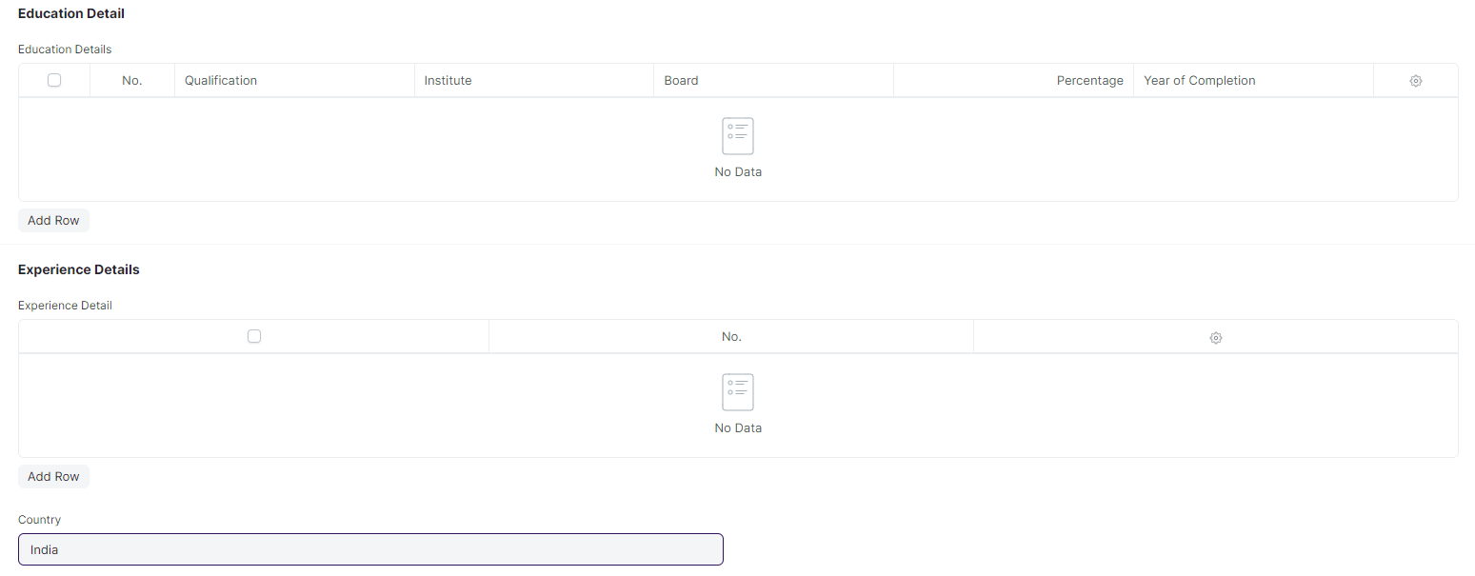

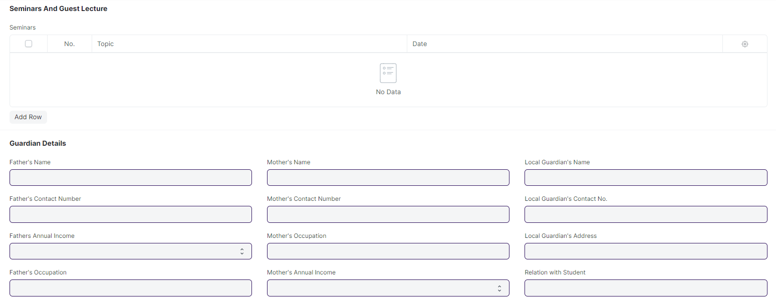

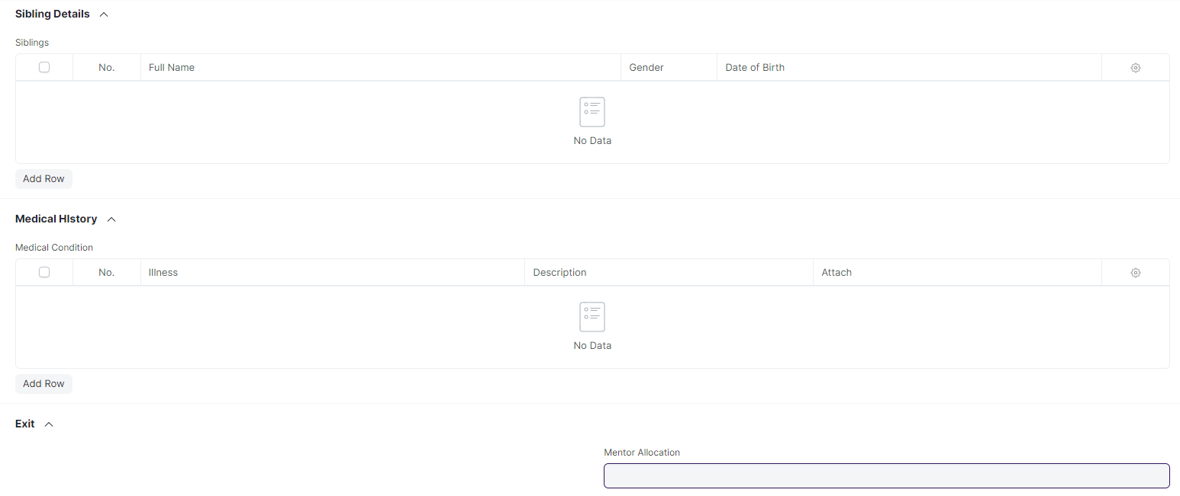

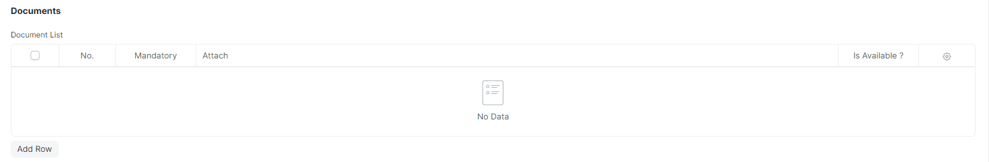

#### **Business Requirements:**

* In Current Education Child Table Programs name need to be rename to Course.

### **Instructor**

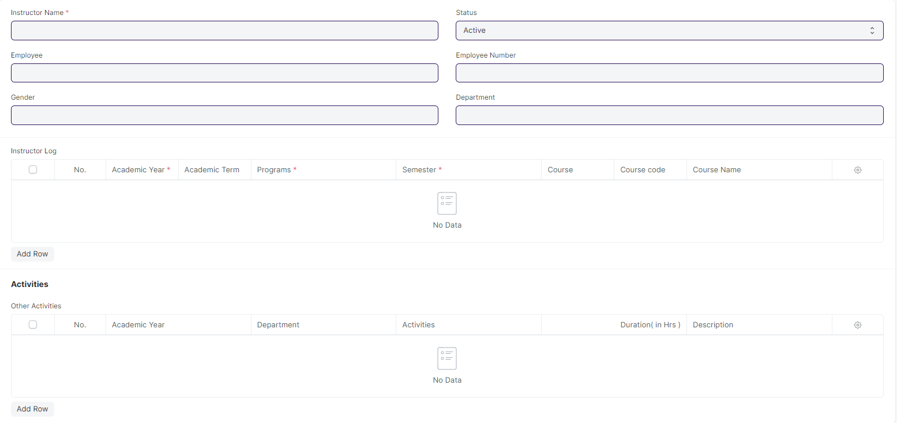

#### **Business Requirements:**

* In Instructor Log child table Programs , Course, Course Code and Course Name rename to Course, Module, Module Code and Module Name.

### **Student Category**

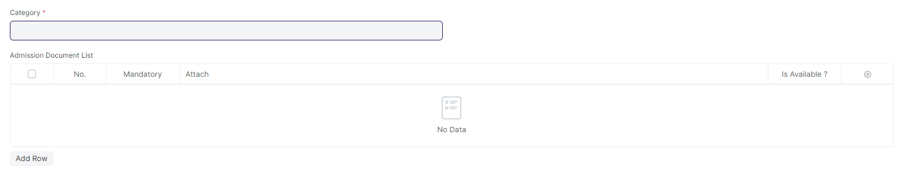

#### **Business Requirements:**

* No changes needed as discussed.

### **Student Batch Name**



#### **Business Requirements:**

* No changes needed as discussed.

## **Admission Master**

### **Academic Events**



#### **Business Requirements:**

* No changes needed as discussed.

### **Academic Calender Template**

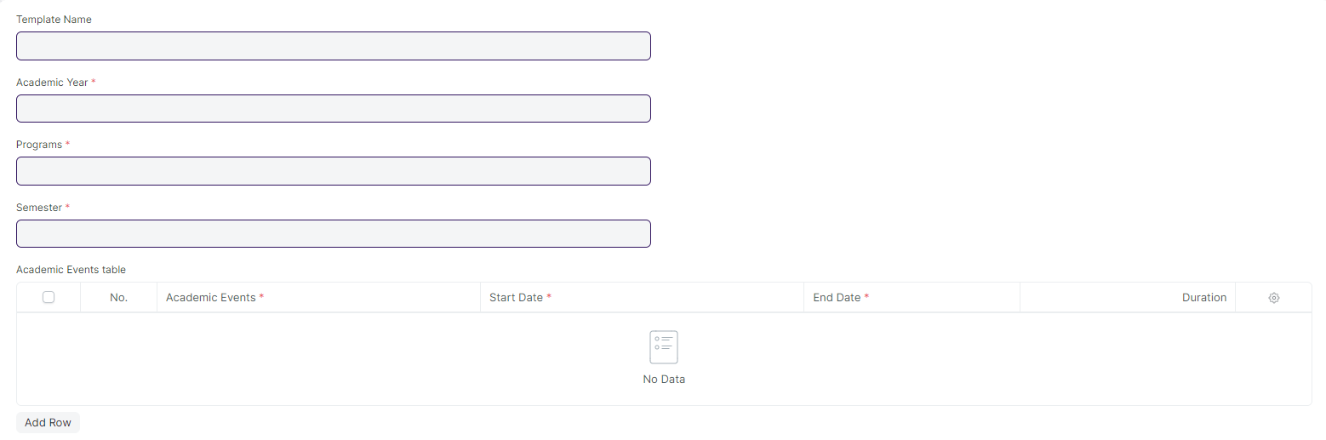

#### **Business Requirements:**

* Different Academic Events, such as Exam Dates, other academic events, and TOT events, should be displayed in a calendar view.

### **Eligibility Parameter**



#### **Business Requirements:**

* An age criteria should be added as an eligibility criteria.

### **Documents Template**

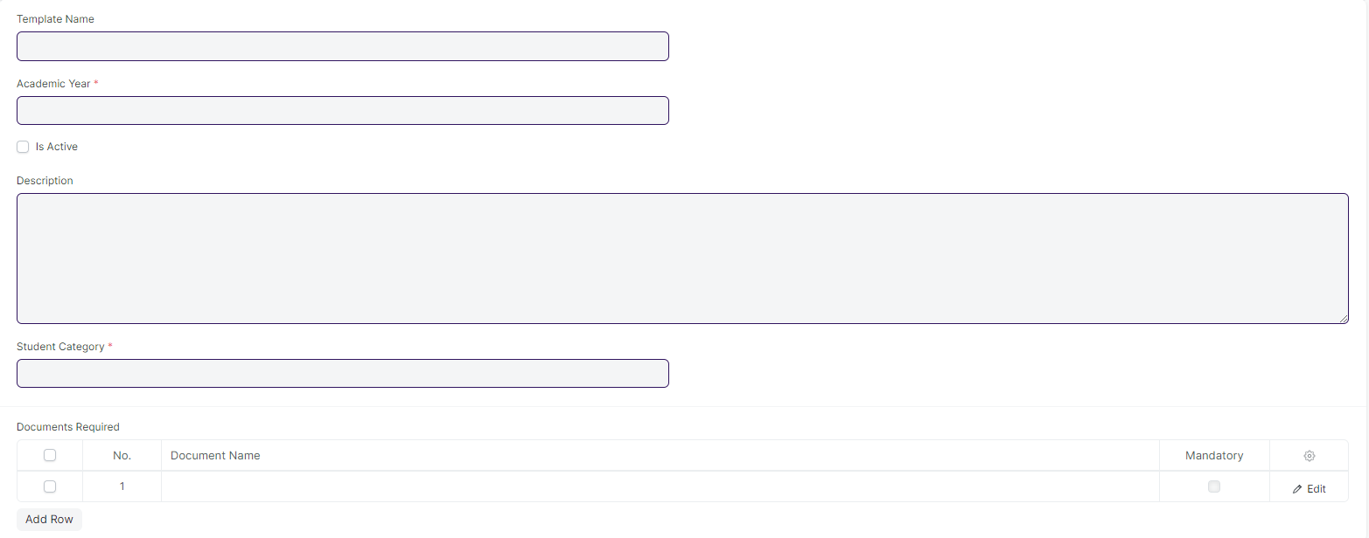

#### **Business Requirements:**

* No changes needed as discussed.

## **Application and Enrollment**

### **Student Admission**

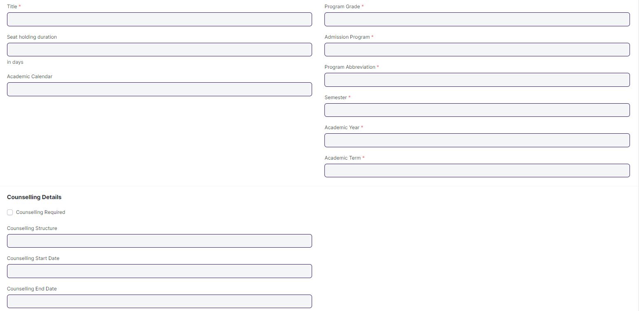

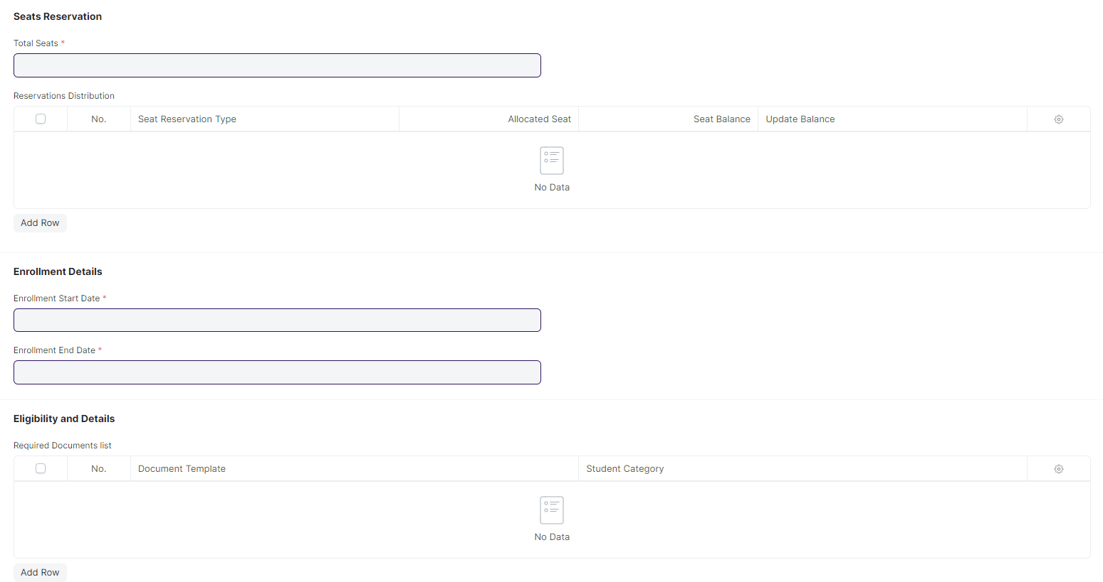

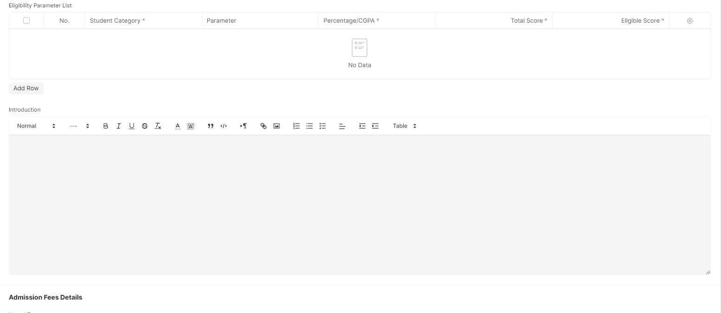

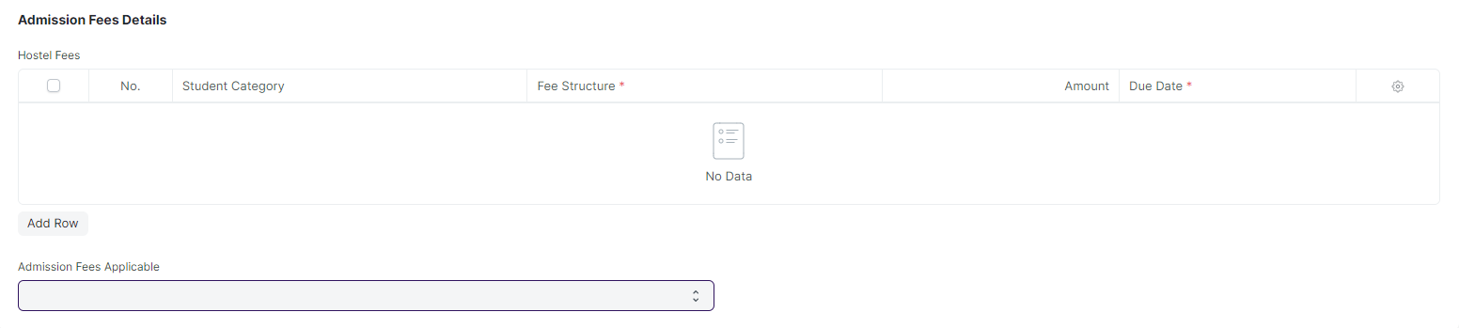

#### **Business Requirements:**

* The following name will be change:

1. Program Grade to Course Grade
2. Admission Program to Admission Course
3. Program Abbreviation to Course Abbreviation

* The age criteria field needs to be added.
* A student who applied and appeared for the entrance exam was selected for counselling but did not choose any course offered then he/she will be rejected.
* If there are still seats available at WSC, they will advertise for Spot Admission, which will allow both new and previously selected students to visit the WSC center to directly apply for admission without having to take a separate exam or fill out a separate form.

### **Student Applicant**

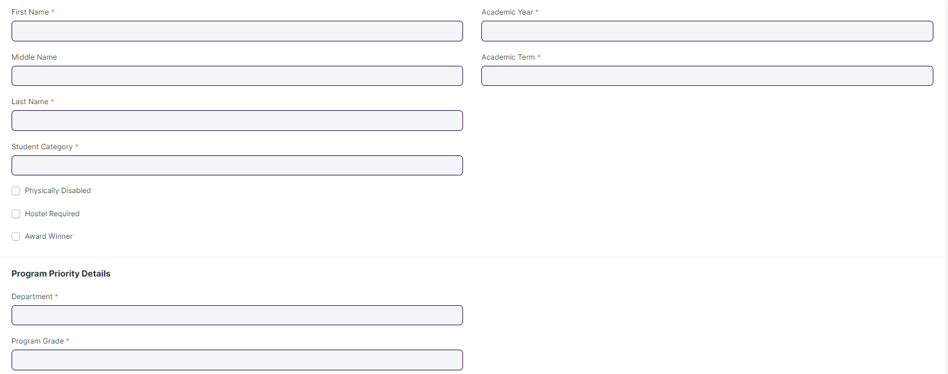

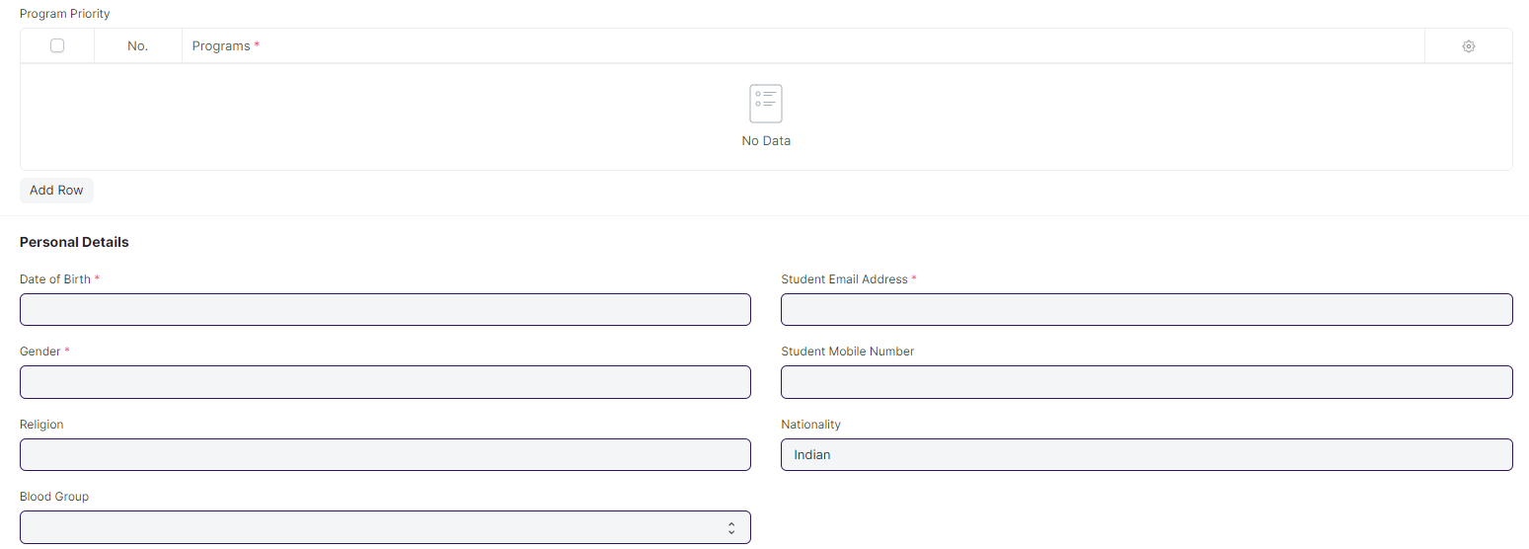

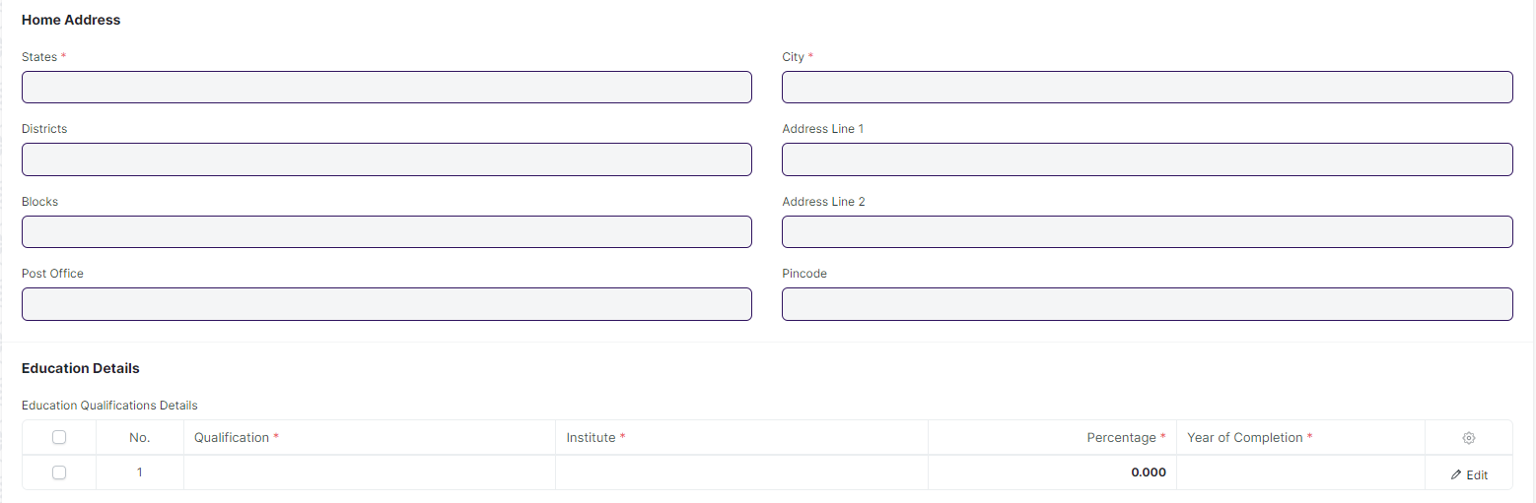

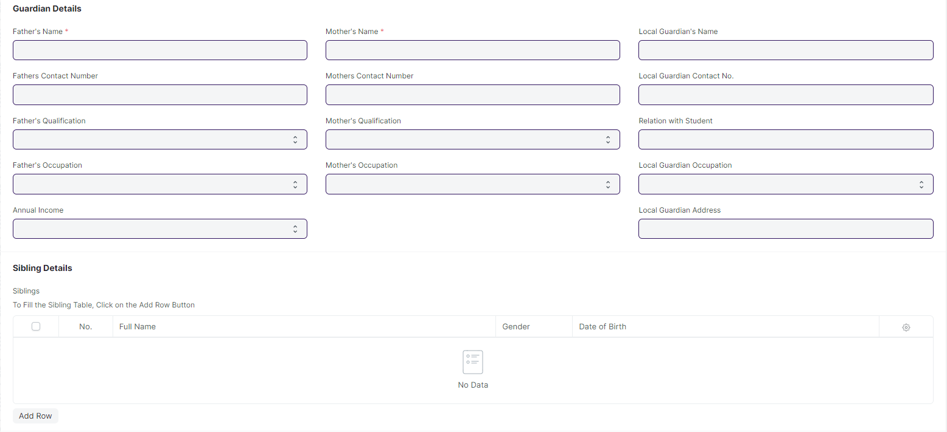

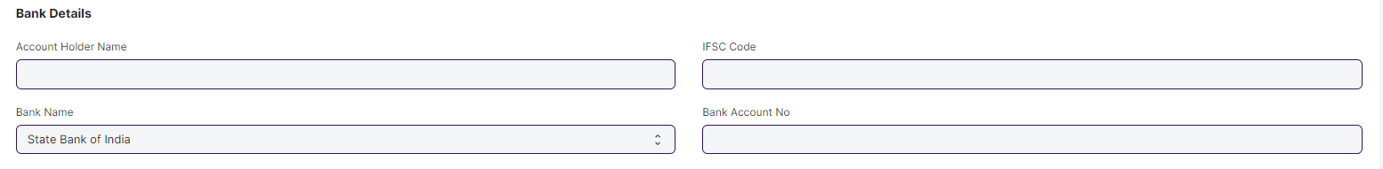

#### **Business Requirements:**

* The **Hostel Required** field will be hidden and the check-in will be set to the default value.
* The City field will be renamed as City / Town / Village
* An option needs to be added for selecting an entrance **Exam Centre** and **Exam City** preference.
* In Exam Center preference following field will be added:

1. State
2. District
3. City/Village/Town

* There will be a Course Choice option currently that will be consider in program priority child table.
* A 3 field needs to added ,General Based Rank, Category Based Rank and PWD based rank . These three fields will be read only and filled after rank card generation
* Some for child tables need to be regarding program priority.

1. Rank Based Program Priority: - In this table the applicant has to give their program preference after rank card generation. Also this table will only appear in the screen after rank card generation
2. Counselling Based Program Priority:- In this table the applicant will give their final program priority during counselling session. As per the program selected from this table the applicant will book a seat for provisional admission.

* The **age** must be validated against the age limit parameter.
* **Following fields will be mandatory:**

1. Email ID
2. Gender
3. Blood Group
4. DOB
5. State
6. District
7. Block
8. City / Town / Village
9. Address Line 1
10. Pincode

* The **Gender** field in the student applicant screen should only have the options of **Male, Female, and Other.**
* The **Email ID** is verified when signing up.
* An option should be available in the system which allows the applicant to apply for **both SOS and SOE**.
* Applicants for **SOE** must have either an ITI or a Diploma in Engineering.
* Applicants for **SOS** must have a +2 certificate or a diploma in any discipline.
* **Rank** will be determined by category, such as **SC Ranking, ST Ranking, General Ranking, OBC Ranking, Total Ranking, SC Woman Ranking, ST Woman Ranking**, and so on.
* **Re-counselling** is done for students who are not able to obtain their desired course.

**Remarks:** The removal of the Bank Details section should be discussed at a later date.

**Student Applicant Admit Card**

* The applicants will need to download admit cards from their portal, which will contain the **Date and time, venue, course, department, address and General instructions** applicable for both **SOE** and **SOS**.

### **Program Enrollment**

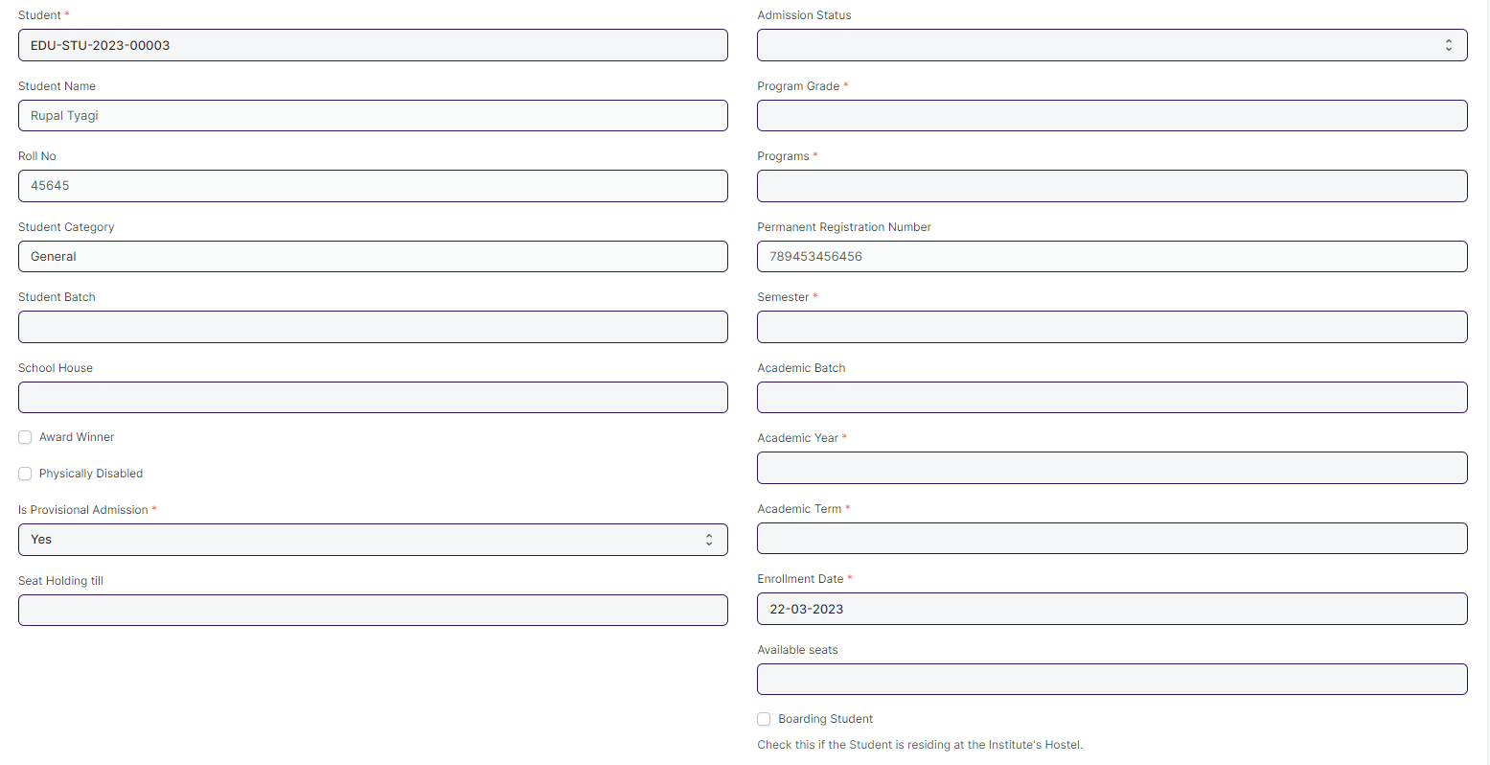

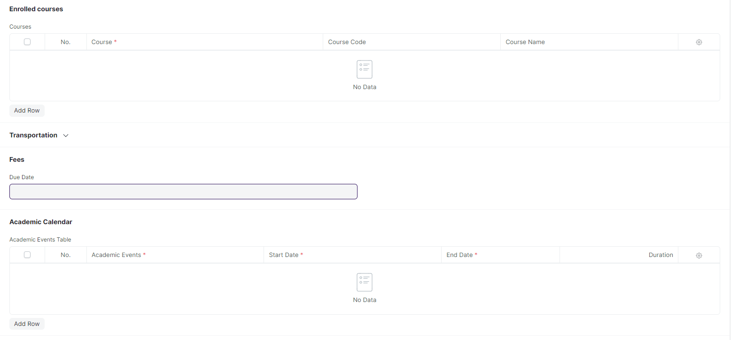

#### **Business Requirements:**

* The following name will be change:
  + 1. Program Grade to Course Grade
    2. Programs to Course
    3. Academic batch need to be deleted
    4. Enrolled Course child table and their respective fields need to be renamed to enrolled Module and course, course code and course name rename to module, module code and module name.

### **Course Enrollment**

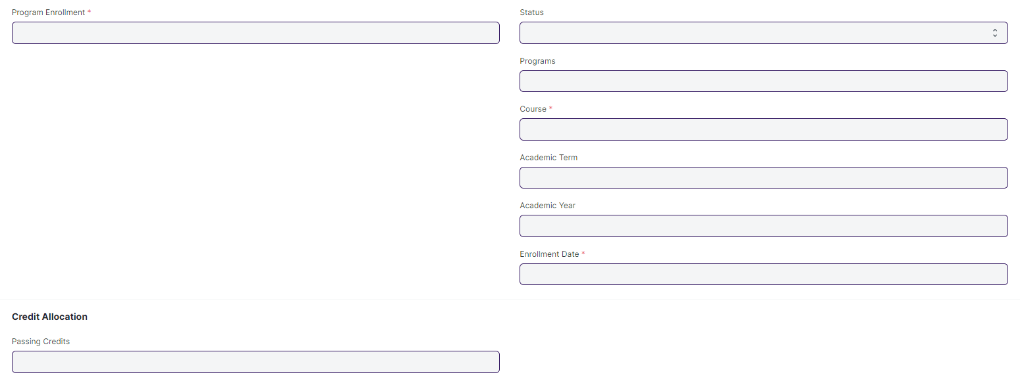

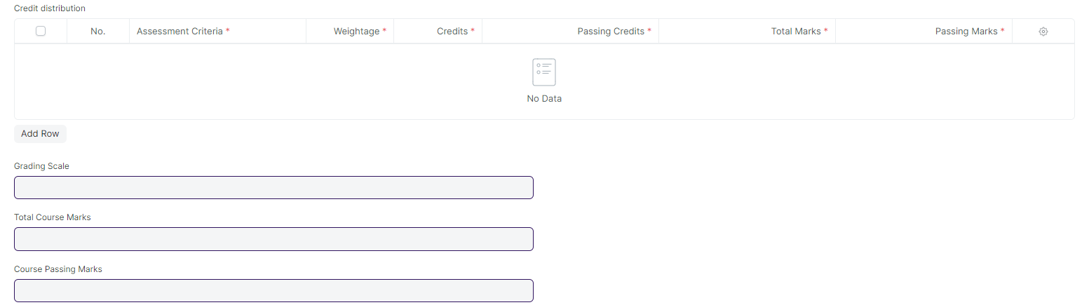

#### **Business Requirements:**

* All the fields and table which is related to credit need to be hidden or deleted.
* Fields need to be renamed:

1. Programs rename to Course
2. Course Rename to Module
3. Program Enrollment rename to Course Enrollment

## **Councelling**

### **Councelling Structure**

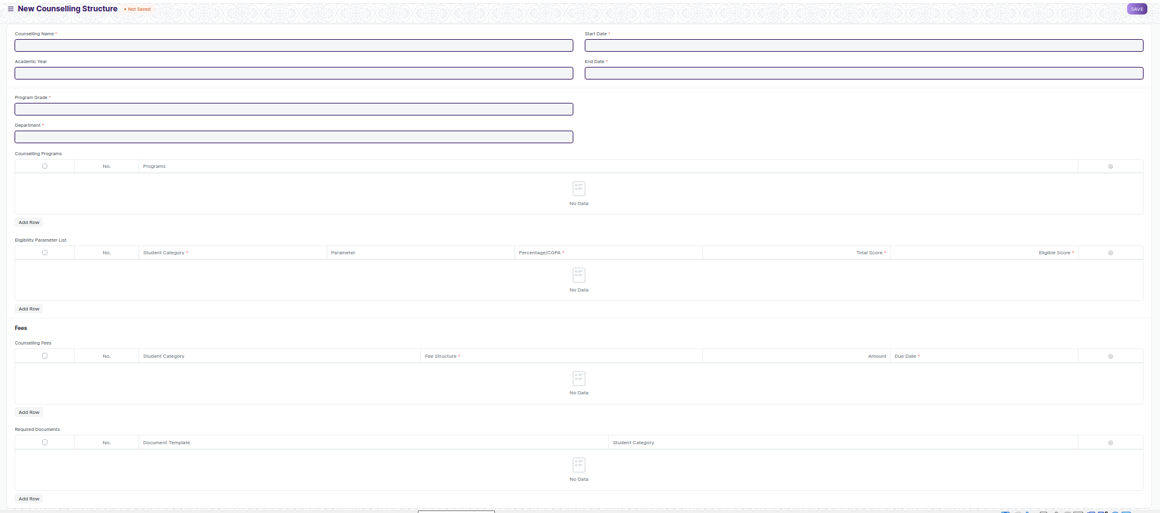

#### **Business Requirements:**

* No changes needed as discussed.

**Note: All Doctypes mentioned below which are part of counselling are new screens that need to made**

### **Place Selection Master**

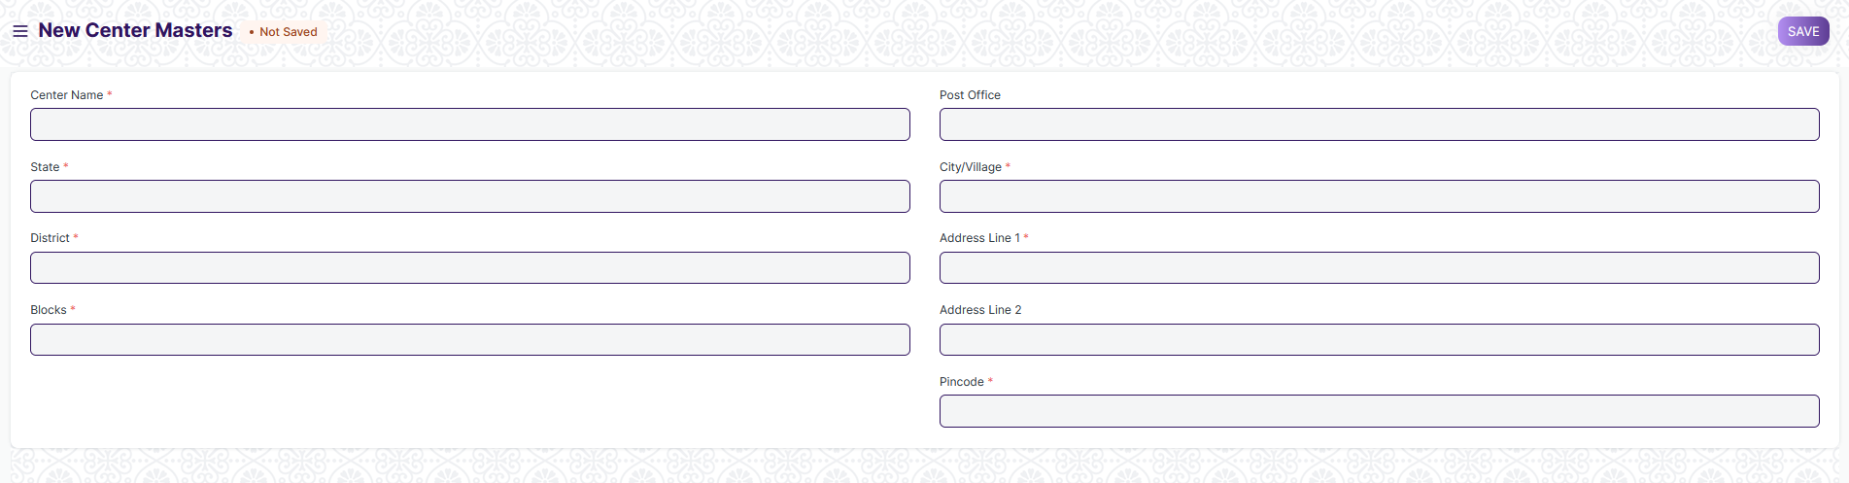

#### **Business Requirements:**

* **A new master screen where basic information regarding a exam centre is stored**
* Mandatory fields include:-
  + Center Name
  + State
  + District
  + Blocks
  + Post Office
  + City/Village
  + Address Line 1
  + Pincode

### **Entrance Exam Declaration**

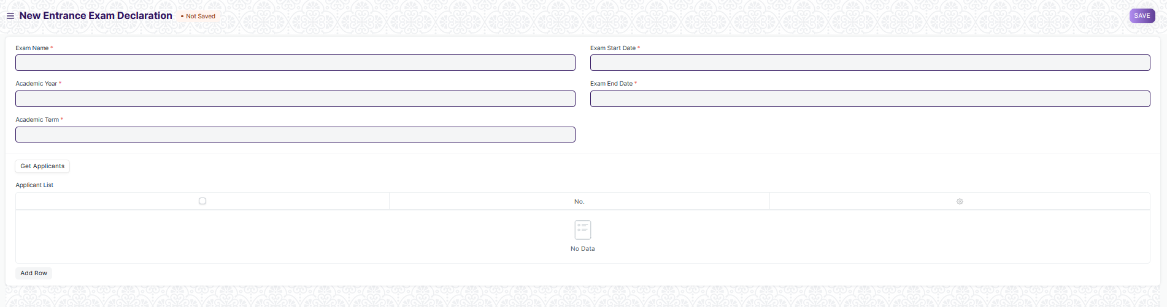

#### **Business Requirements:**

* A new screen where information regarding upcoming exams are stored
* Mandatory Fields include:-
  + Exam Name
  + Academic Year
  + Academic Term
  + Exam Start Date
  + Exam End Date
  + Applicant List

### **Entrance Exam Center Allocation**

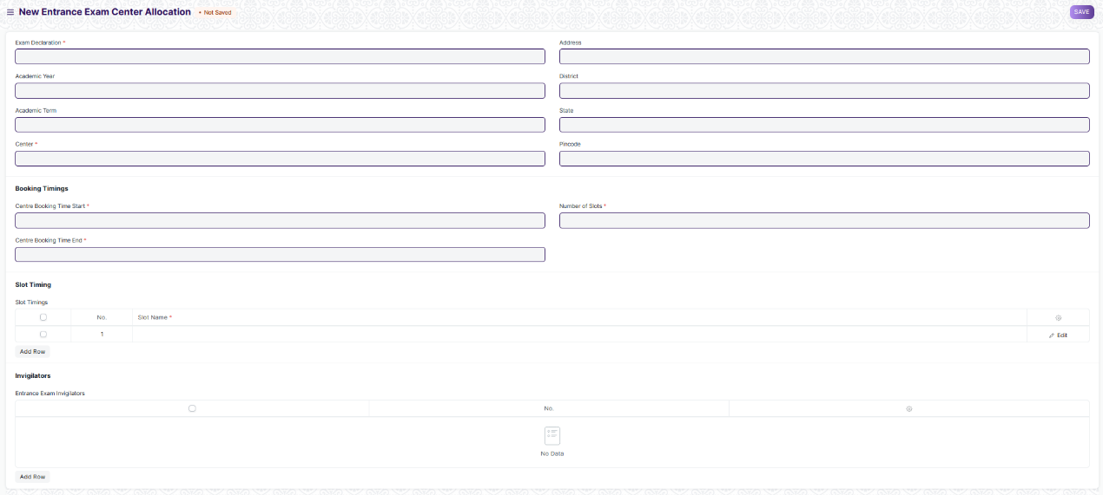

#### **Business Requirements:**

* **A screen where the information regarding exam location and date for the entrance exam is to be allotted and stored.**
* Mandatory Fields include:-
  + Entrance Exam Declaration
  + Exam Date
  + Center Booking Time Start
  + Center Booking Time End
  + Number of Slots
  + Slot Timings
  + Entrance Exam Invigilators

### **Admit Card Generation Tool**

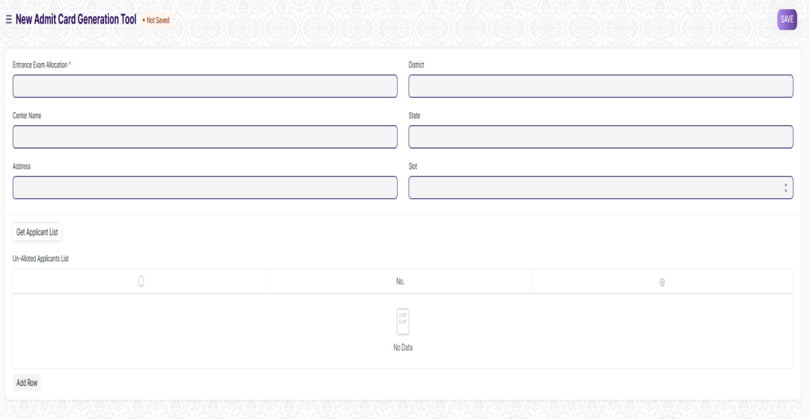

#### **Business Requirements:**

* **A tool to generate multiple admit cards for applicants and also alots them a venue for the exam**

### **Entrance Exam Admit Card**

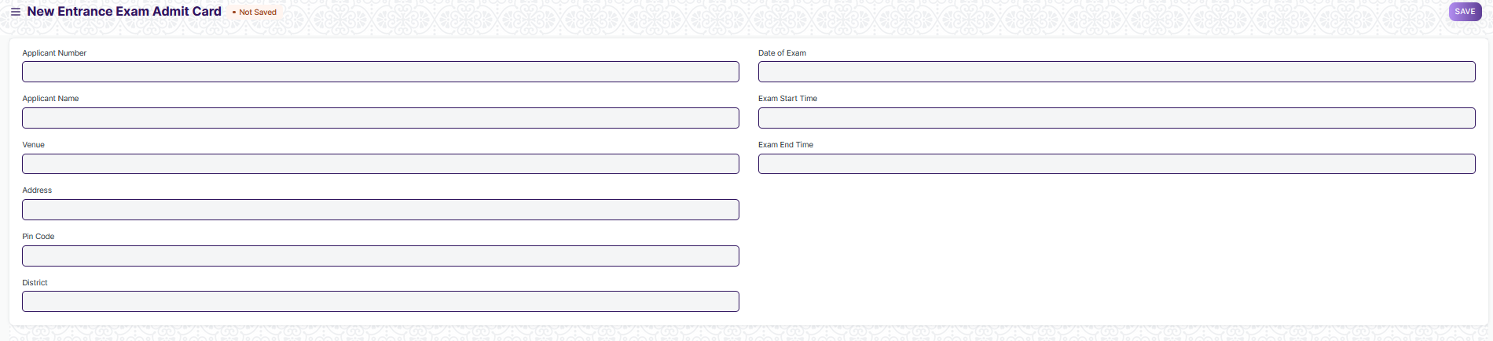

#### **Business Requirements:**

* **A screen which holds information of an individual students admit card**
* **Most of the data in this field will be filled by the Admit Card Generation Tool**

### **Entrance Exam Evaluation**

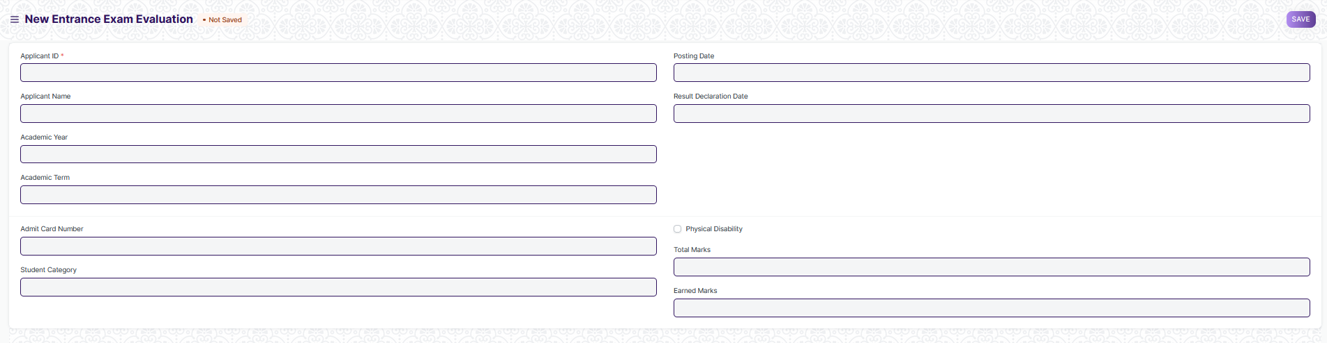

#### **Business Requirements:**

* **A screen which contains the marks of an applicant for the entrance exams**

### **Rank Card Publication Tool**

### 

#### **Business Requirements:**

* **A screen which used to make large number of rank card**

### **Rank Card Publication Masters**

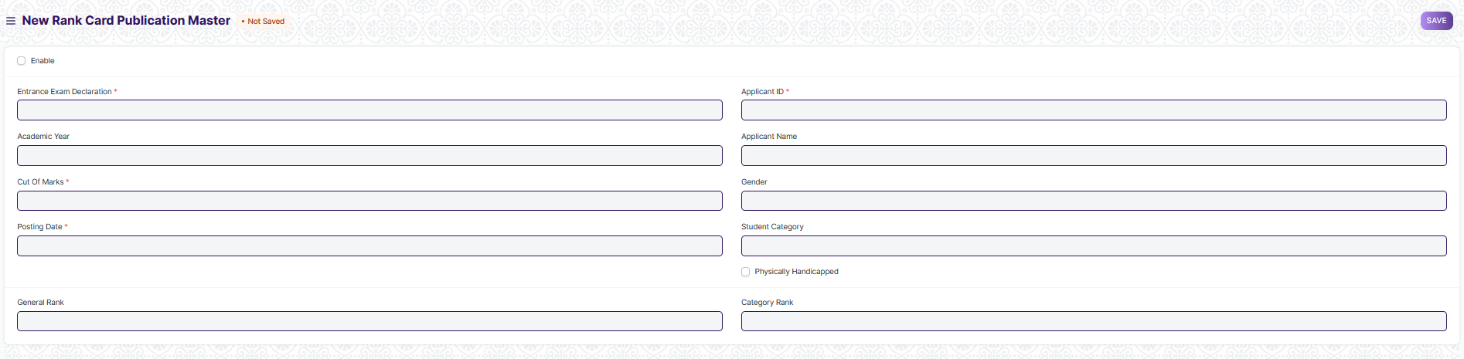

#### **Business Requirements:**

* **A screen which contains the information regarding an applicants rank obtain in the entrance exam.**
* **There is a per-determined cutoff for obtaining a rank. If an applicant didn’t clear the cutoff marks, then he/she won’t be provided with a rank**

## **Fees**

### **Fee Structure**

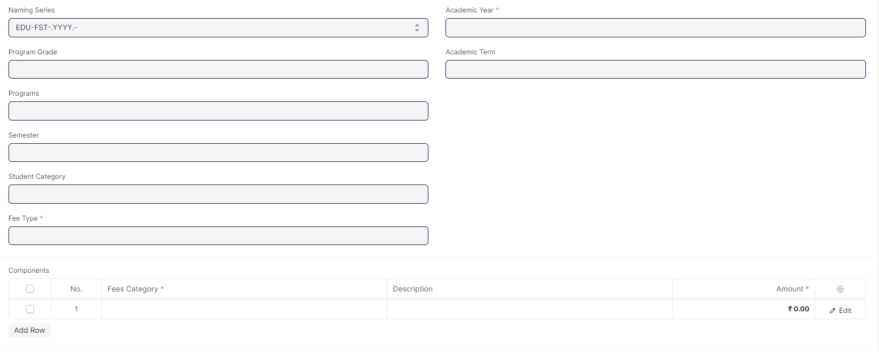

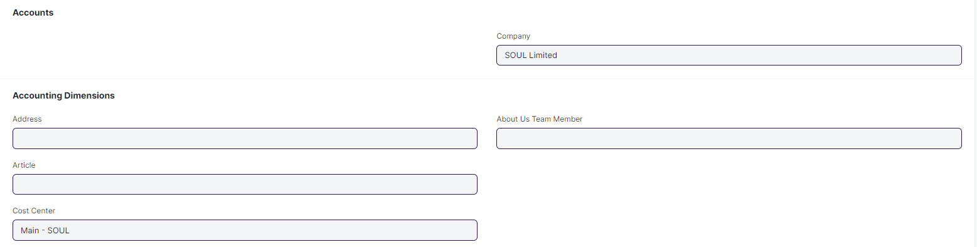

#### **Business Requirements:**

* No changes needed as discussed.

### **Fee Schedule**

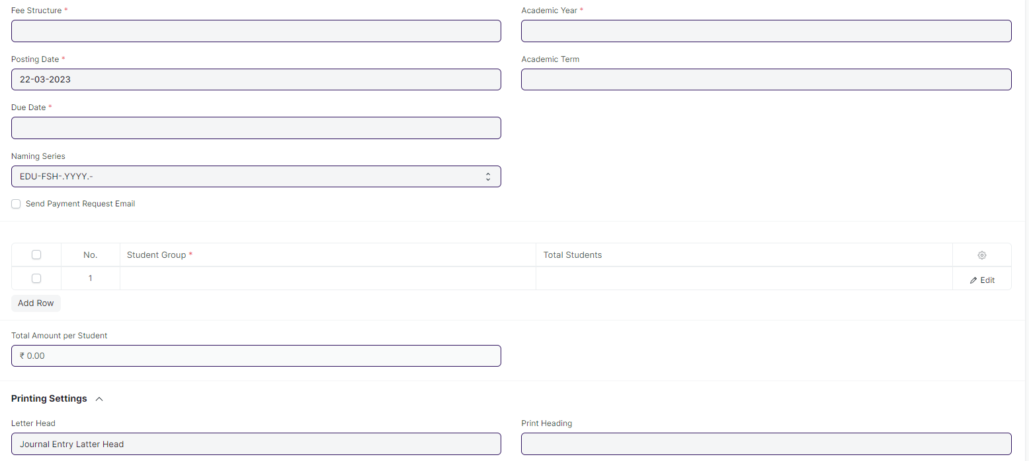

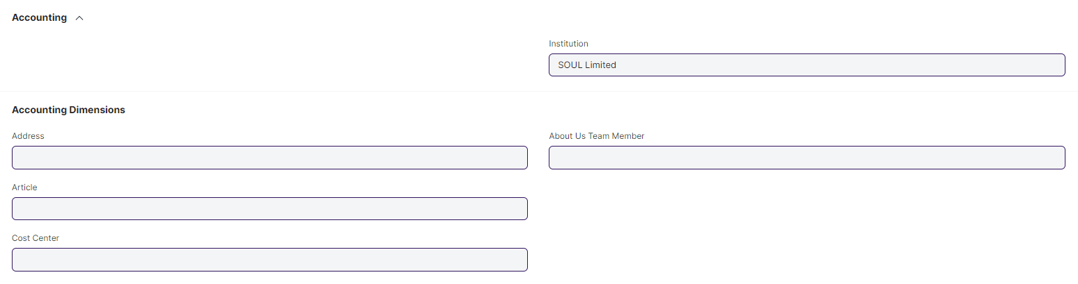

#### **Business Requirements:**

* No changes needed as discussed.

### **Fee Category**

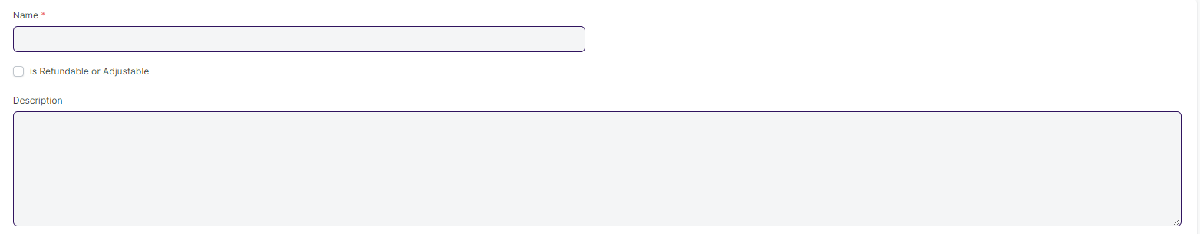

#### **Business Requirements:**

* No changes needed as discussed.

### **Fees**

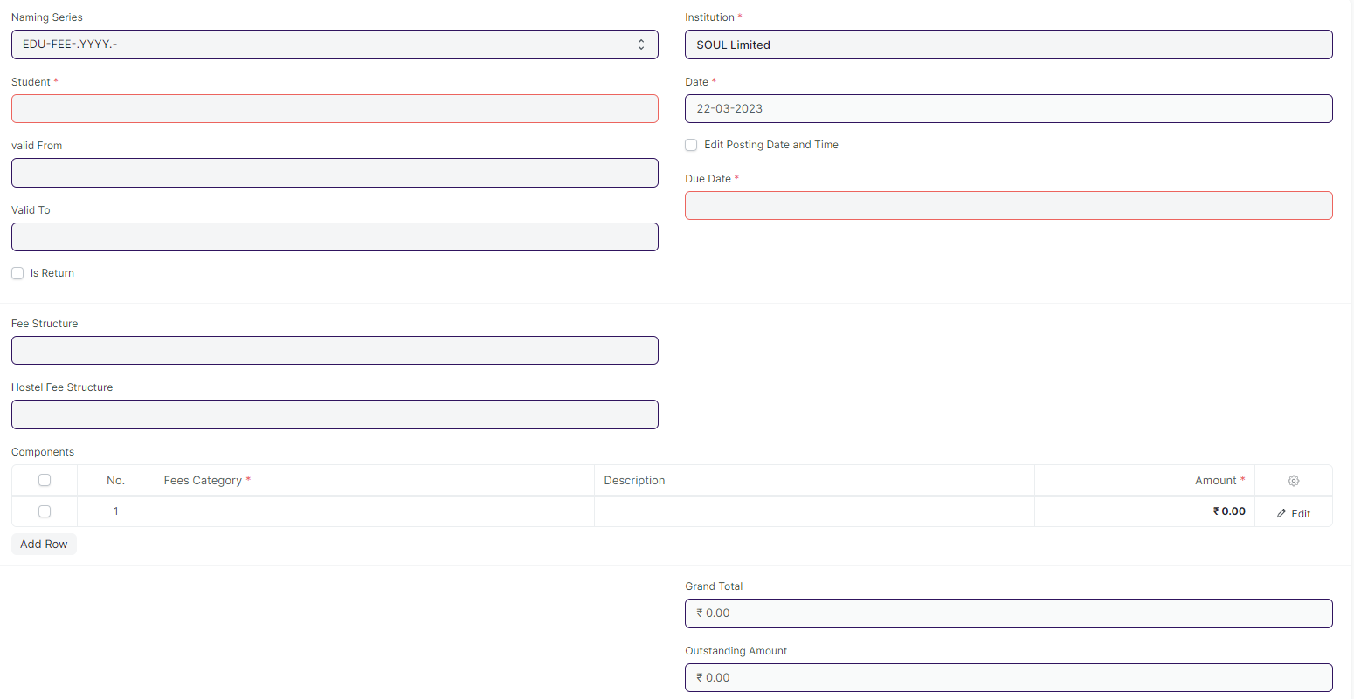

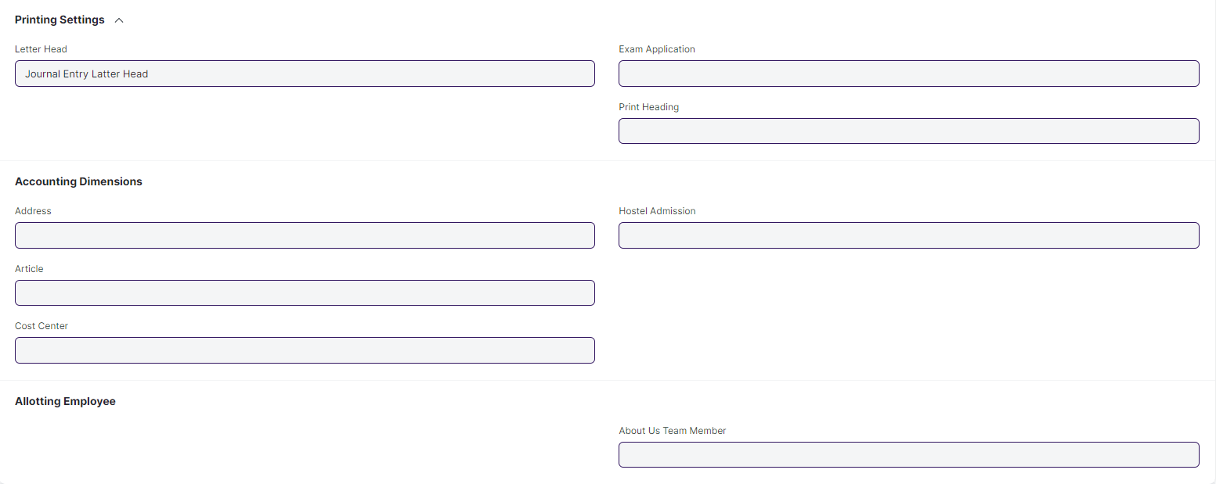

#### **Business Requirements:**

* No changes needed as discussed.

## **Tools**

## **Student Re registration Tool**

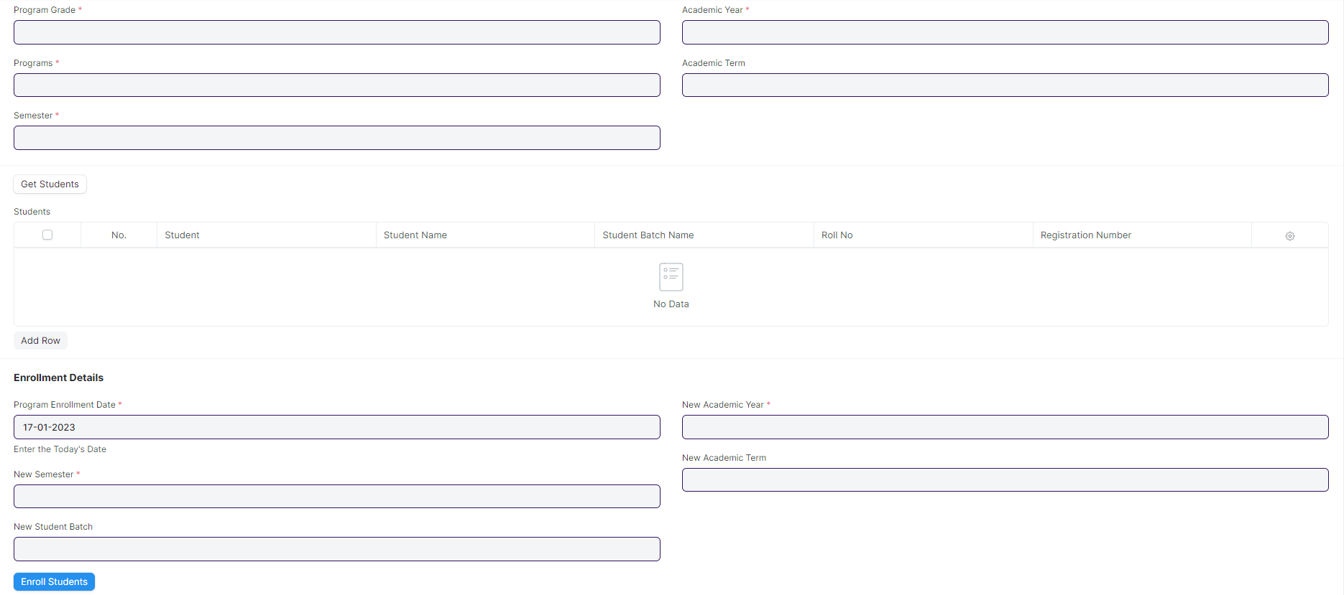

#### **Business Requirements:**

* Program Grade and Programs need to be change to Course Grade and Course.
* And Course Child table need to be change to Module.